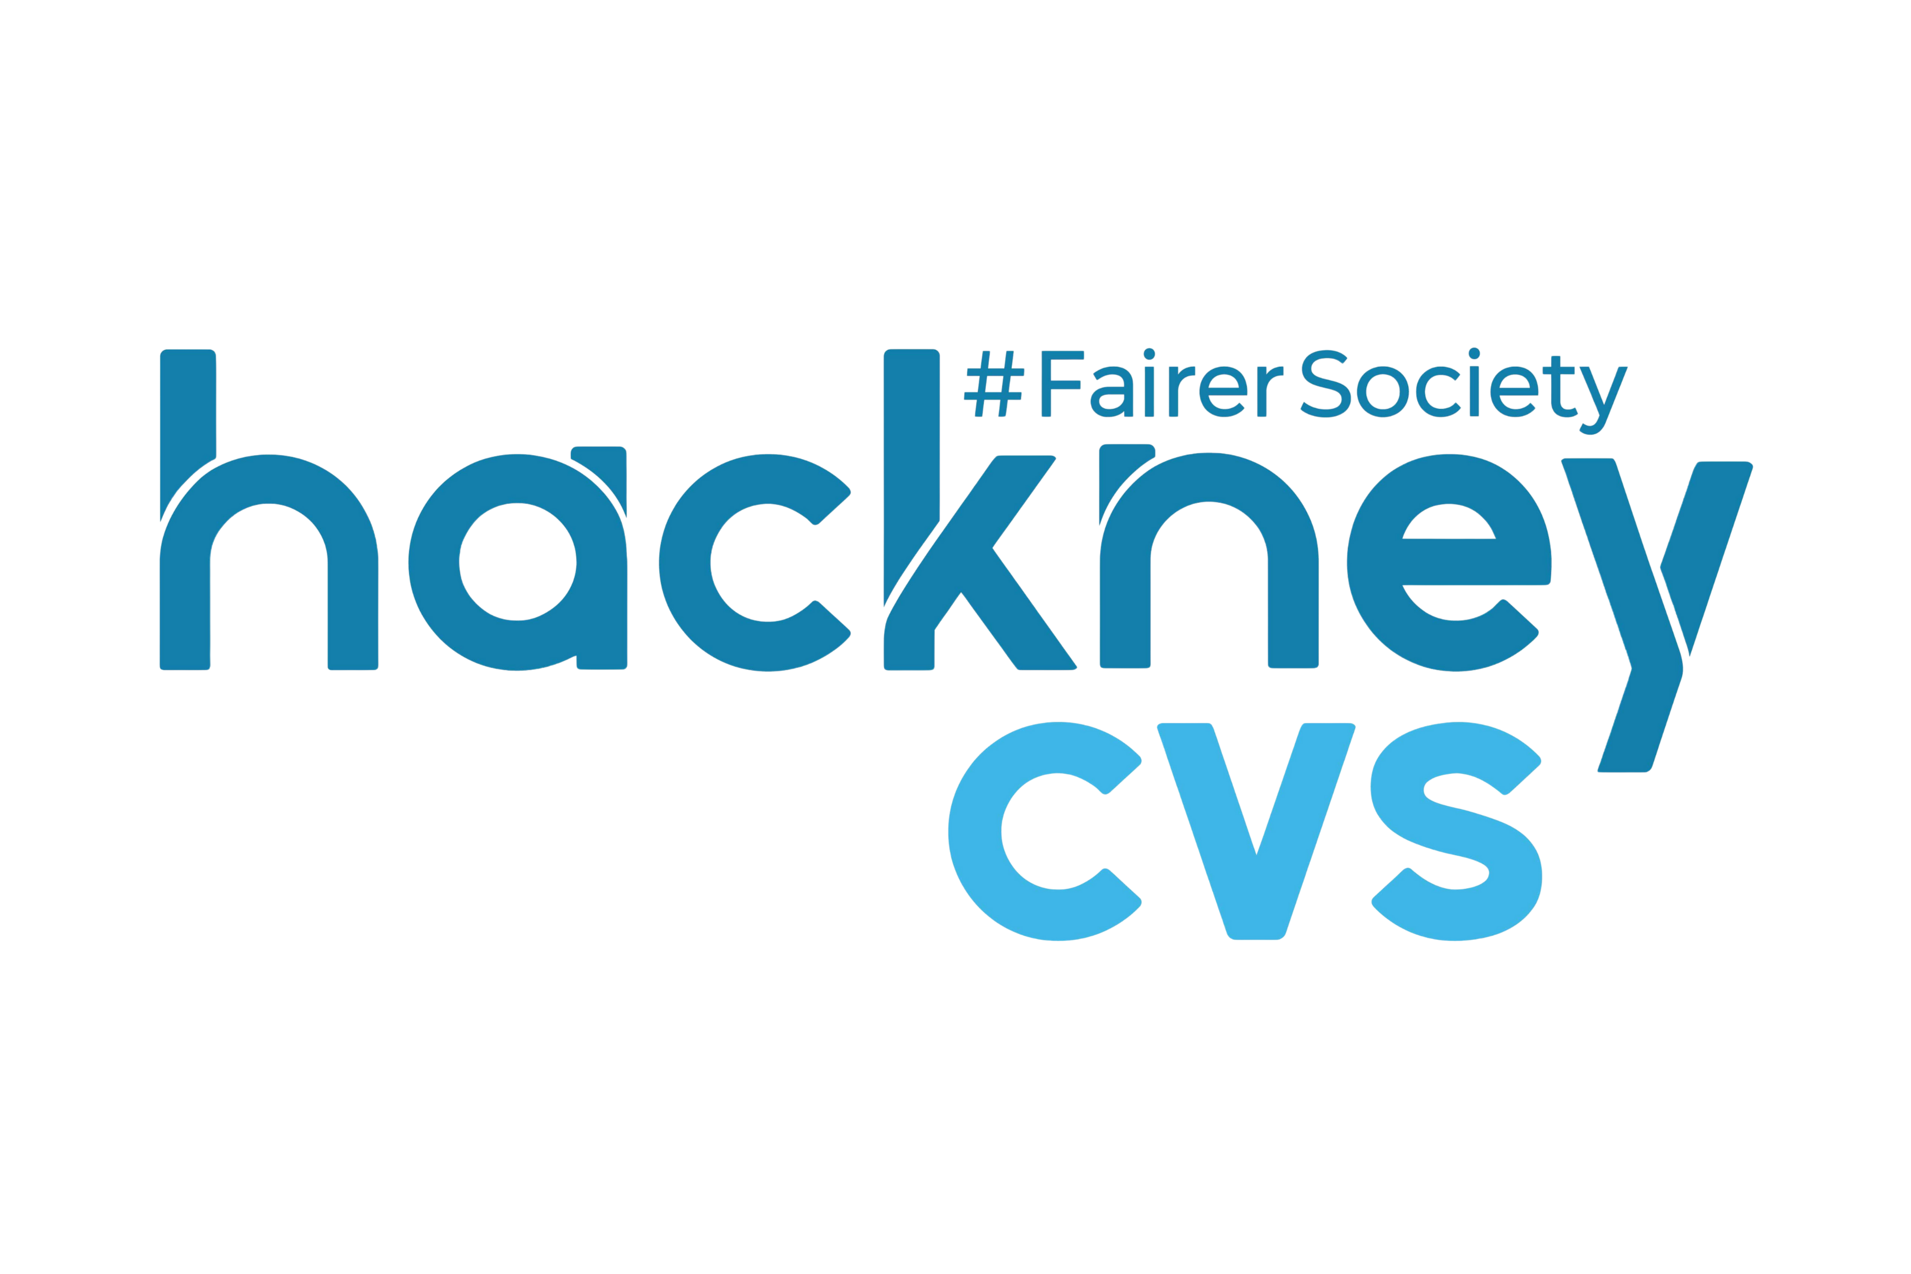
t: 020 7923 1962 | e: reception@hcvs.org.uk | www.hcvs.org.uk
The Adiaha Antigha Centre, 24-30 Dalston Lane, London, E8 3AZ
Registered Charity No: 1069736 | Limited Company No: 3365292

HACKNEY CVS COMPLAINTS FORM

If you wish to make a complaint about Hackney CVS, please complete this form and return to the relevant contact stated below:

For complaints regarding Data Protection (for example personal data)
Compliance
Hackney CVS
24-30 Dalston Lane, E8 3AZ
Email: compliance@hcvs.org.uk
Tel: 020 7923 1962

For all other complaints
Mark Boisson
Director of Finance and Resources
Hackney CVS
24-30 Dalston Lane, E8 3AZ
Email: mark@hcvs.org.uk
Tel: 020 7923 1962

If you have any difficulties completing this form please contact Mark Boisson on the email or phone number above.

CONTACT DETAILS OF COMPLAINANT

Your Name:

Your Organisation (if applicable):

Your Address:

Email:
Tel no:

ABOUT THE COMPLAINT

Date of complaint:

Who is the complaint about? Name of staff member/trustee (if known)

Please tell us about the nature of your complaint in the space below. (If more space is needed, please continue on another sheet and attach it to the form):

Please tell us what you would like the expected outcome to be:

