Improving Outcomes for Young Black Men in Hackney - Programme Summary 2018-22

Background

The Improving Outcomes for Young Black Men Programme (YBM) is an ambitious programme to tackle inequalities for black boys and young black men in Hackney. We are moving into our third full year of a ten year partnership programme. Outcomes data, stakeholder views and community insights were synthesised to develop and agree a high level theory of change in December 2015. More detailed plans were adopted in 2016 and for the first two years we have focused on establishing the building blocks for a longer term programme. These building blocks are a combination of activities which build commitments from partners as well as testing and learning from effective practice.

At the heart of the programme are a group of Inspirational Leaders, a group of young black men, who have been trained as community leaders to engage and inspire other young black men, and who help co-produce solutions. We now have a far more informed idea of the issues that are driving inequalities for young black men and of what solutions are needed. This new plan sets out the new strategic direction for the next four years from 2018-22.
The partnership is convened by London Borough of Hackney and chaired by the Statutory Deputy Mayor and Cabinet Member for Children and Young People, Councillor Anntoinette Bramble. The full partnership meet every six months, with a range of working groups progressing work in between. The programme is overseen by an officer group made up of officers from London Borough of Hackney and Hackney CVS, which meets every six weeks.
Since the Local Elections in 2018, the Programme has been underpinned by two of the Mayor’s manifesto commitments:
# 3 We will tackle poverty, including child poverty, as well as key inequalities in health, education and employment based on a solid understanding of the barriers and needs of our different communities, listening to their concerns and expanding the use of social value and co-design.
# 84 [We will support] those that face disadvantage, through projects like the Young Black Men’s Programme.

Demographics
The largest group of African people in Hackney are Black African. This is also the third largest ethnic group in Hackney, Black African (11.4%) is third to White British and Other White. We have seen an absolute increase of 15% (+3686) since 2001 although the proportion of black Africans in the overall population has dropped slightly (0.6%) as Hackney’s population has grown. The increase in the Black African group has been seen at a regional and national level, both proportionately and absolutely. The Black African population has increased from 1% percent to 1.8% across England, and from 5.2% to 7% across London. This growth is both due to birth rate and to recent international migration. 18,088 residents listed an African country as their country of birth in 2001 and this figure rose to 21,506 in 2011.
Conversely, the Black Caribbean population in Hackney (7.8%) has decreased since 2001 both in absolute and relative terms, along with a few other populations Irish (-15%), Pakistani (-12%), and White British (-1%). The proportion of people who say they are mixed heritage has increased in proportion and absolute number since 2001, both for mixed White and Black Caribbean and mixed White and Black African. In 2011, there were 4,614 young (age 16 to 24) black (including Black British and also Mixed: White and African and Mixed: White and Caribbean) men.
The proportion of the local population who are of Black and Black Mixed Heritage varies considerably by age.
- 34% of the male population aged 0-15 years old are of Black and Black Mixed Heritage (i.e. Black British, Mixed: White and Black African/Caribbean)
- 29% of the male population aged 16-24 years old are of Black and Black Mixed Heritage
- 27% of the male population aged 18-24 years old are of Black and Black Mixed Heritage
- 15% of the male population aged 25-34 years old are of Black and Black Mixed Heritage
- 33% of the male population aged 0-24 years old are of Black and Black Mixed Heritage
- 24% of the male population aged 0-34 years old are of Black and Black Mixed Heritage

From our research we have identified a range of indicators that highlight the ways in which young black men experience disproportionately poorer outcomes. We have examined data and insight which helps us to understand outcomes compared with the wider population, and outcomes compared with other young men, as well as analysing data and insight by different sections of the black diaspora. It is important to note that there will be some issues that may be common to young black men regardless of their social or cultural background and other identities and there will be other issues that are specific to some groups of young black men.
This research has consequently influenced the priority areas for the programme moving forward. Some of this data is presented in this life course of a young black man.
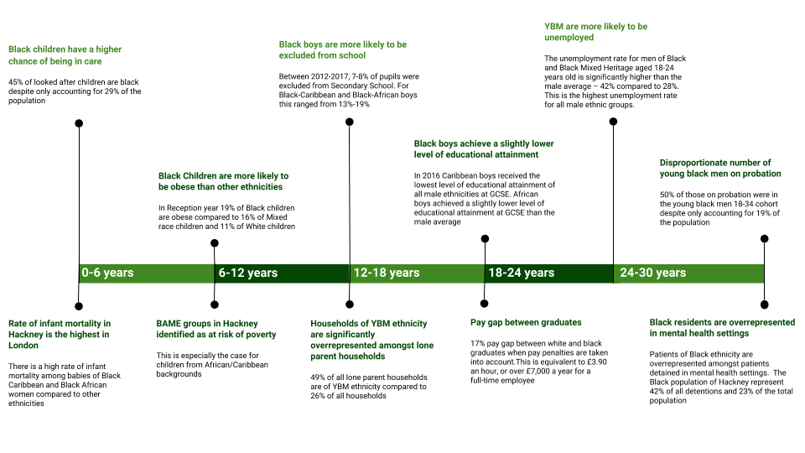
Success to Date
Examples of successes to date:
- A group of headteachers have been leading work in their schools to address inequalities in exclusions, behaviour and achievement – recognising the impact that the individual actions of a school can have on the wider community. They will be sharing their findings with other schools at a conference in February 2019 and making the case that change is needed in all schools.
- The local Clinical Commissioning Group (CCG) have set up a Reach and Resilience Programme as part of the Child and Adolescent Mental Health Service (CAHMS) to address specific community issues and community solutions; through this, East London Foundation Trust and HCVS have developed a successful way of supporting mental wellbeing in a community sector - based on a strengths based approach- which is demonstrating how young black men can be engaged in early help and support.
- The Moving on Up Programme at HCVS was delivered between 2015 and 2017 with funding from Trust for London to engage young people on issues around employability. The programme worked with 123 young people, 58% of whom had positive job outcomes. The programme learning is now influencing DWP plans; Hackney has been identified as a challenge area because of ethnic inequalities in employment.
- In response to issues raised through the YBM programme, ELBA have identified investment from three corporates to develop the Parity Programme which offers bespoke employment support to help different cohorts of black men into corporate roles in London.
Despite successes and progress, the programme is operating in a challenging environment. There are areas of public policy which are set and driven nationally, which appear to be less effective for black boys and young black men (exclusions in education, funding and models for mental health, the criminal justice system) and the recent spate of serious violence across London has disproportionately impacted on black men. However the programme is starting to have some influence national and regional policy, as there is greater receptivity to understanding the impacts of race and racism on outcomes, with the set-up of the Racial Disparity Unit and the Lammy Review.

The Racial Disparity Unit’s first focus has been on employment, and their funding specification makes specific reference to modelling Hackney’s approach. DWP have now identified Hackney as a Challenge Area, and because of the YBM Partnership, we were ready to influence and shape these plans. The work in schools has been presented at Institute of Education conferences. The Greater London Authority, London Councils, Birmingham City Council, Lambeth Council, Haringey and Kensington and Chelsea have all shown interest in the work we have been doing.

What have we learnt to date
At the beginning there was a great deal of dissonance to work through in the early days of the partnership. There is now a more unified view of the reasons for the programme and the drivers for inequalities.There are some key lessons to share about how this has been achieved which have now been embedded into our approach:
- Creating a safe and open space for partnership working (and a “no blame culture” where partners can talk about uncomfortable issues) and where different perspectives are listened to and valued.
- Encouraging a culture that develops solutions in a multi-dimensional way, looking at what can be changed at an individual, community, institutional and societal level, along with a recognition that the current ways of working, whether in the community or public sector are not tackling the underlying issues.
- Adopting an open approach that has brought different stakeholders around the table from the outset, and put young people and the community at the heart of the work, so that there is a transparent round table approach to developing solutions.
- Being steered by rich insight and intelligence, rather than being led by strong voices.
- Developing our confidence as a partnership to talk confidently about race and consider how it might be driving inequalities alongside other factors. Research has shown that the public sector is very unconfident and fearful about having conversations about racism and race and looking at institutional racism.

Our Approach
Drivers of Inequality
In seeking to understand what is driving the disproportionality of outcomes, we need to adopt an approach which is multidimensional and considers what is driving inequality that might be linked to:
- Direct or indirect discrimination based on gender, age, ethnicity and the intersection of all three.
- Contextual or cultural drivers e.g. lack of trust between the community and state, cultural barriers.
- Poverty and socio-economic inequality – the black community is more likely to be in low income households in Hackney and experience other socio-economic inequalities. This socio-economic inequality is a structural inequality that can ultimately be linked back to racial disadvantage and discrimination.

To drill down to what is driving inequality, we have examined data and insight which helps us to understand outcomes compared with the wider population, and outcomes compared with other young men, as well as analysing data and insight by different sections of the black diaspora as shown in the life course of a young black man we have produced. We have also considered qualitative perspectives from the community and stakeholders about the barriers and issues and reviewed evidence of what works.
One of the challenges throughout this programme, is ensuring that we do not over-privilege the individual account or anecdote, but that we consider it alongside other accounts and other data to look for trends and patterns. As mentioned previously, a challenge is recognising that there will be some issues that may be common to young black men regardless of their social or cultural background and other identities and there will be other issues that are specific to some groups of young black men.

Theory of Change
A theory of change approach has been adopted to help partners respond to their shared long term ambitions. The theory of change approach enables us to map back from the long term outcomes we want to achieve, identify the underlying drivers for inequality and agree the changes that we want to see. It enables us to identify and test assumptions taking a questioning approach rather than narrowing down to conclusions too soon. Given that the challenge to improve outcomes for young black men is not new and is a widely debated and a contested topic, it seemed particularly important to find an approach that allowed for solutions to be developed through engagement and debate, underpinned by data and evidence.
In responding to the drivers of inequality we need to understand what changes are needed within:
- Individuals and the community
- Institutions
- Wider society

We need to take a whole systems approach and expect recommendations to include changes which are:
- Universal- bringing about changes for everyone
- Making an offer or service more inclusive
- Targeted to address a specific cohort by ethnicity, gender, age, socio-economic group or an intersection of these

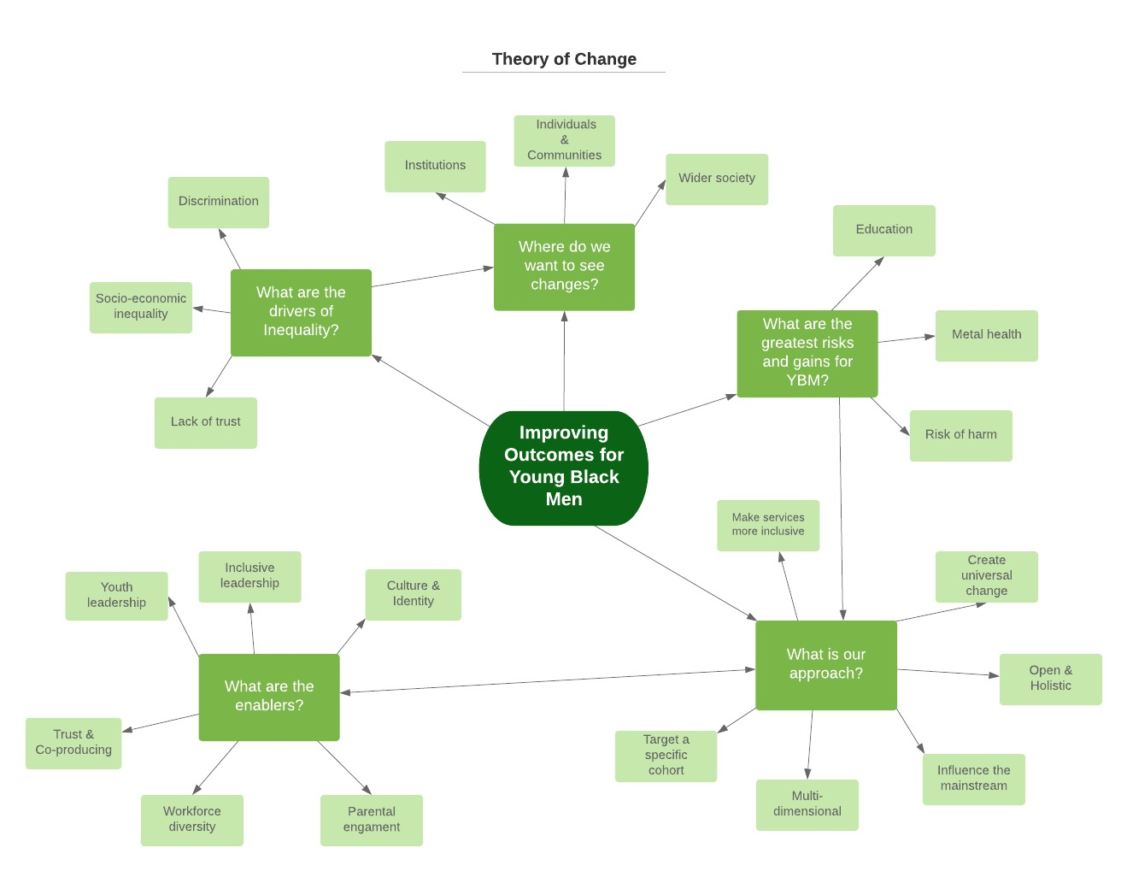

Setting a New Strategic Direction
The full partnership met in March 2018 to review progress since 2016 and again in July 2018 and November 2018 to steer the development of the new plan. This plan focuses on fewer proactive work-streams, than in the first two years. We have prioritised the areas where there are the greatest risks and gains to be made to improve outcomes for young black men.

1. Education
Key inequalities
- Overall, boys achieve a slightly lower level of educational attainment at all stages of education. Caribbean boys achieve a lower level of educational attainment than both the male average and average for African boys at all stage of education.
- At Primary School Caribbean boys made up 22% of fixed term exclusions in 2014 compared to 5% of the school roll. At Secondary School Caribbean boys made up 17% of fixed term exclusions in 2014. This compares to Caribbean boys making up 5-6% of the school roll.
- African boys are slightly over represented amongst fixed term exclusions at both Primary School and Secondary School. At Primary School in 2014 African boys made up 14% of fixed term exclusions compared to 11% of the school roll. At Secondary School in 2014 African boys made up 14% of fixed term exclusions compared to 9% of the school roll.
- Nationally, Black Caribbean and White British children eligible for free school meals are the lowest performing ethnic groups of children from low income households.
- Nationally, in 2016 travellers of Irish heritage and Black Caribbean pupils had the highest proportion of pupils with SEN statements or Education and Health and Care plans (4.7% and 4.2% respectively) compared with a national average of 2.8%.
What are the drivers?
- The intersection of different equality issues
- Family and home factors
- School factors
- Leadership issues about equality
- Low expectations of black boys
- Valuing culture and identity
- Transition to secondary school
- Negative peer influences

Progress
Disadvantage Project
Four schools, Cardinal Pole, Stoke Newington, Skinners and Bridge have been undertaking work in their schools to address the attainment and exclusions gap.

Headteachers’ Group
A group of 28 Headteachers have been leading work across their schools to identify key issues to address to improve outcomes focusing on support around transition, student leadership and partnership working.

Decolonising Education – practitioner led work
Young Hackney are working with students and teachers to understand and reshape how the curriculum can be more inclusive. As well as how teachers can best respond to challenging behaviours, support for young people to reach their potential and delivery of the national curriculum.

Outline Action Plan
Supporting vulnerable pupils:
- Transition: School transition processes need to continue to be strengthened with a focus on vulnerable and at risk learners including black boys.
- Multi-agency working needs to be strengthened with a focus on hard to reach parents in volunteer participating schools, both primary and secondary.
- Focus on reducing exclusions - by schools identifying alternatives to exclusions; HLT reviewing their approach – to be informed by deep dive.
- Monitor impact of CAMHS support workers in 40 primary schools to inform CAMHS Transformation Plans.
- Reduce exclusions by schools self identifying ways to find alternatives to exclusion through scrutinising how pupils’ behaviour is presented differently using CAMHS tools and support.

Institutional culture and workforce:
- Workforce: Pilot schools to promote effective recruitment processes to better support a strong profile of black role models.
- Engagement with governors to develop their role in tackling key inequalities.
- Inclusive leadership – a) create a group of change agents so that training on inclusive leadership and cultural competency can be disseminated into schools over next two years b) finance needed to recruit academic expertise.
- Embedding the leadership of the programme even more firmly in schools.

Parental engagement:
- Schools needs parental liaison link role.
- Some schools looking to trial parental advocacy work to avoid exclusions in two of the four schools working with community partners.

Sharing learning:
- Headteachers will share their learning with a wider range of schools in conference in February 2019.
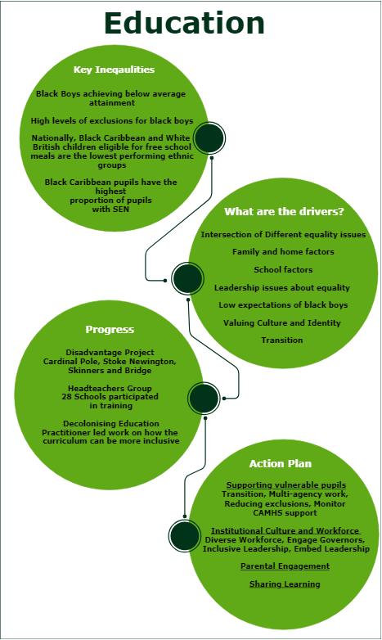

2. Mental Health
Key inequalities
- Black Caribbean children are overrepresented in CAMHS cases. The total of CAHMS specialist cases for Black-Caribbean and Mixed White-Black Caribbean ethnicity is 10.3% compared to an under-18 GP population of 5.2%.
- In Acute Mental Health Teams, children and young people of Black-African (17% vs 9.8%) and Black-any other ethnicity (14.9% vs 10.3%) are over-represented while Black-Caribbean children and young people are under-represented (2.1% vs 3.4%).
- Black patients are also more likely to be receiving secondary mental health care than other ethnicities. Amongst patients with a Serious Mental Illness diagnosis Black patients are over four times as likely to be receiving care from East London Foundation Trust (ELFT) compared to White patients – 1.4% vs 0.3%.
- In City and Hackney centre patients of Black ethnicity are over-represented amongst patients detained in mental health settings. In total, the Black population of Hackney represent 42% of all detentions and 23% of the total population. Black men are detained at a slightly higher rate than women.

What are the drivers?
- The Intersection of different equality issues
- Society/environment
- Culture & Family
  - Family life/Stigma
- Institutional Issues
  - Suitably of provision
  - Crisis Support
  - Trust & Confidence in the system

Progress
Review services and resources and offer to understand access and inclusion issues.
This will all be used to help design features of a support which addresses the access and inclusion issues identified. It will also be used to inform the new Mental Health Needs Assessment which will be completed in 2019.

Look at how clinical support can be offered to alongside other wellbeing/recovery support in an integrated care plan – with a better understanding of how trauma can be managed.
The BME Access team at ELFT and HCVS recommend testing and evaluating delivery of therapy embedded into the community setting, and delivered by the clinician known to them, alongside the delivery of signposting support.

Challenging institutional programmes for Hackney providers that tackles racism
ELFT have rolled out unconscious bias workshops for recruitment, but more work is needed to address institutional issues in service delivery across the system including police sections.

Improve information about mental health services, especially targeting young black men
A study was commissioned by the CCG into the perceptions and experience of mental health. The key findings were that there were high levels of stigma and fear associated with mental health, with some indication this might be linked to their cultural background.

Mental health first aid (MHFA) training rolled out in different settings
Public Health have invested £25k in MHFA to 200 practitioners working with young black men to improve awareness and information about support services and improve resilience.

Outline Action Plan
Objective 1: Young people access early help and support more quickly
- Share findings of review of mental health services to identify ways to make services more accessible and inclusive of black boys and young black men.
- Develop a more flexible and accessible clinical offer that provides early support to black boys and young people, addressing key barriers and inequalities.
- Ensure that CAMHS workers in schools meet the needs of black boys who have mental health needs.
- Develop a richer understanding of the extent to which mental wellbeing is a driver of behavioural issues and exclusions.
- Ensure that young people have access to community based wellbeing and recovery services.
- Ensure that people who work with young black men are better able to identify mental health needs and signpost people to help.
- Ensure that young people who need it receive support and advice to prevent substance misuse within youth settings.

Objective 2: Black families and young people are less suspicious of psychiatric services / less fearful of being labelled as someone with mental health needs
- Tackle stigma and fear of the mental health system through one shared partnership approach.
- Develop a programme for Hackney providers that tackles overt and covert racism and seeks to achieve a more demographically representative workforce.
- Establish an overview of how diverse organisations are across the mental health system, and what key actions are being taken to address gaps in workforce diversity.

Objective 3: Wider policy decisions take account of mental wellbeing impacts.
- Build an understanding of the wider environmental factors that impact on mental wellbeing and show how young black men are in the one of the groups most disproportionately impacted.
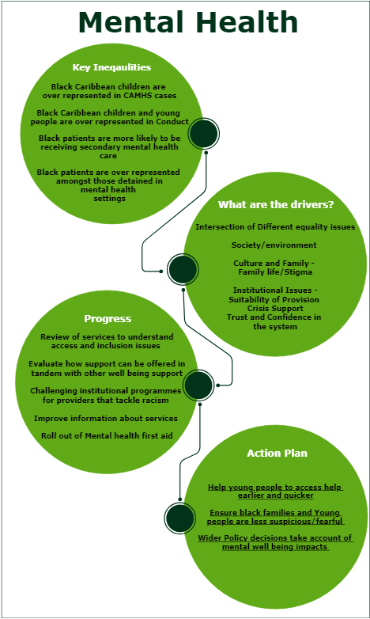

3. Reducing Risk of Harm
Key inequalities
- Black children are overrepresented amongst Looked after children - 45% of Looked after Children are Black compared to 29% of the population aged 0 to 19 years old.
- Hackney has seen a spike in serious violent crime and homicides over the last few years. According to the Metropolitan Police, murders on the street are nearly always gang or drug related, and young black men are overrepresented in these homicides.
- Young people of Black ethnicity are consistently the group most likely to be First Time Entrants to the Youth Justice System – making up between 40-50% of First Time entrants. Only a third of the population aged 10-17 years old are of Black ethnicity.
- People of Black ethnicity are the least likely, of all ethnic groups, to say that the Police treats everyone fairly regardless of who they are (63% vs. 77% overall).

What are the drivers?
- Family life
  - Complex Needs
  - Parenting Challenges
- Institutional issues
  - Police
  - Reaching & Engaging those that are at risk
  - Critical Points & Transition
  - Staying up to date with intelligence

Progress
Engage with hospitals about plans for preventative work following knife injuries
There is already youth work embedded in the major trauma unit at Royal London, as part of a MOPAC funded programme. The providers, Redthread, have been working with the Homerton Hospital to roll out a similar approach in Hackney and have been awarded a LBH community grant to develop a project from April 2018.

Engage the local courts to try to address the disconnect between the judiciary system and the local community context
Work with lawyers who act as representatives for YBM – to identify their views on ways that outcomes can be improved when YBM enter criminal justice system
We invited local courts and judges to a meeting to seek to share insights from the YBM programme and look at sentencing, support for offenders and institutional culture. We could not secure interest and are identifying alternative ways to engage with the judiciary, some of whom said that this issue was too “political.”

Facilitate partnerships between probation and organisations that take a more holistic approach
It has been very difficult to engage with probation over the last year, especially the CRC. We are keen to trial a longer term integrated approach.

Deliver a programme of engagement and research to understand levels of trust in policing
Youth offending
The Youth Offending team had been the subject of a recent inspection and was assessed to have good engagement with young people. An improved support offer to the Courts had resulted in a decrease of 50% in the number of young people being taken into custody.

Gangs / Knife Crime
The Integrated Gangs Unit has capacity to manage 150 individuals and that only 9% of this group are under 19. Over the last year, the Community Safety Partnership have been developing a knife crime strategy.

Outline Action Plan
1. Reduce incidence of YBM experiencing or causing harm within their family
- Establish and review domestic abuse interventions and outcomes for Black and Mixed ethnicity families.
- Establish and review the use of universal and targeted/specialist antenatal services for Black and Mixed ethnicity families.
- Establish and review outcomes of health visiting service for Black and Mixed ethnicity families.
- Establish and review outcomes of universal, targeted and specialist children's centre services for Black and Mixed ethnicity families.
- Establish and review provision, access and outcomes of sexual education for young Black men.
- Establish and review type of Children and Families referrals and interventions for Black and Mixed ethnicity families.

2. Reduce incidence of YBM experiencing or causing harm within their school
- Establish and review what information is generated by and provided to schools about a young people’s vulnerabilities before entering school and prior to and during each academic year and how agencies support these children.
- Establish and review provision, access and outcomes of the education provided in schools about harmful behaviour and keeping safe for young Black men.
- Establish and review how primary schools respond to in-school harmful behaviour and subsequent responses for Black boys.
- Establish and review how secondary schools respond to in-school harmful behaviour and subsequent responses for Black boys.

3. Reduce incidence of YBM experiencing or causing harm within their community
- Provide accessible and effective information and advice and support to parents/carers of Black boys and young Black men and members of the public about services and interventions relating to extra-familial risk.
- Deliver awareness-raising about extra-familial risk across locations, focusing on areas and in communities where need is likely to be highest for young Black men.
- Establish and review the rate and response to anti-social behaviour incidents for young Black men.
- Establish and review the rate and response to stop-and-search for young Black men.
- Establish and review rate and outcomes of the Gangs Matrix for young Black men.
- Establish and review rates and responses to non-violent crime for young Black men.
- Create a whole-system case work approach to reducing extra-familial risk for YBM regardless of a young person’s perpetrator, victim and or bystander designation or the type of harm they are at risk of causing or experiencing.
- Establish and review how Black boys and young Black men disclose and/or indicate extra-familial risk to health professionals.
- Establish rates and responses to violent crime for young Black men.
- Monitor media coverage of young Black men in Hackney and develop a media strategy for promoting more positive coverage for this group.
- Establish and review reoffending for Black boys and young Black men (both for Youth Justice and National Probation Service).
- Create a unified whole-system case work approach to addressing extra-familial risk once harm has occurred - including reoffending - regardless of the perpetrator, victim and/or bystander designation, conviction or the type of harm that has occurred.

4. Improve understanding of the impact of harmful behaviour across the life course for YBM in Hackney
Actions
- Map for an agreed cohort the extent to which young Black men are coming to the attention of agencies with issues indicating harm and carry out an analysis based on the identified case history with each key agency. Use this analysis to promote learning and system change across the partnership.

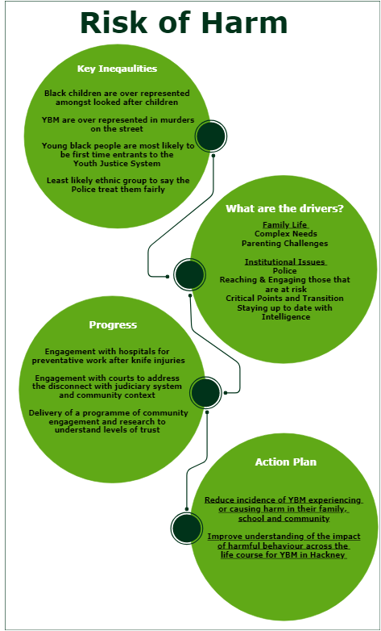
Fundamental Strands
The following strands are seen as fundamental to successful outcomes for young black men:

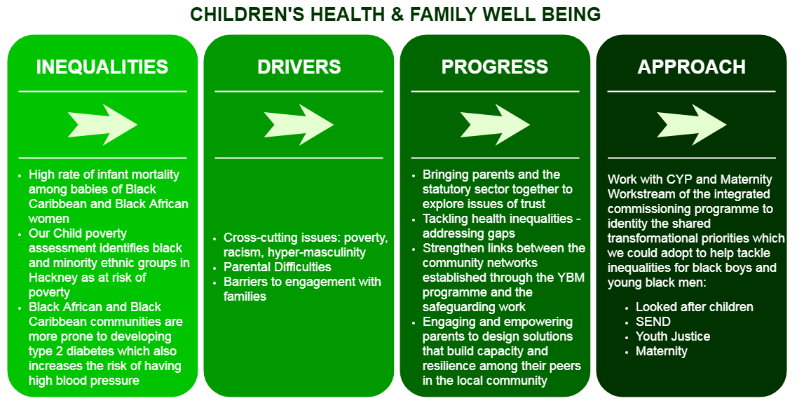

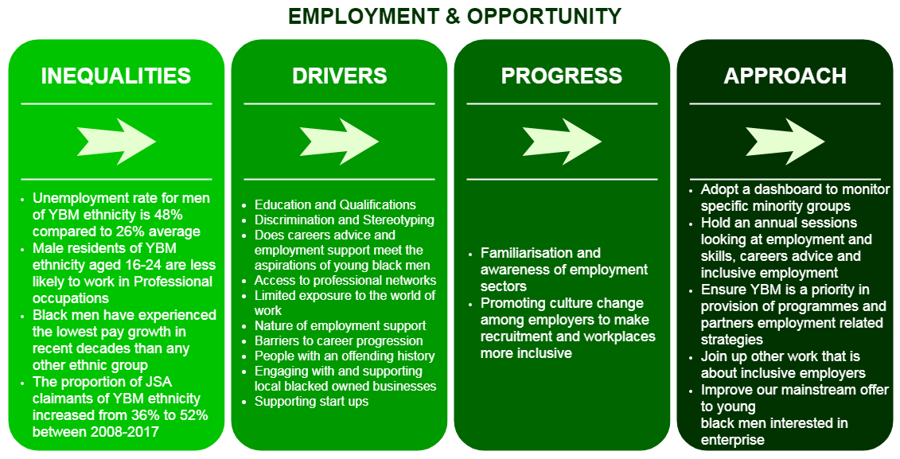

Institutional enablers
We are going to progress the institutional enablers in order to create the right environment and culture for the outcomes outlined above to improve.

Inclusive leadership culture and workforce diversity
All partners on the Young Black Men Programme undertook racial identity training. For example, presentations and workshops on racial identity were then arranged to all CYPS managers and staff, racial identity training was run for young people in residential in October and ELBA ran an Inclusive Leadership session with corporates in January. In January 2018, Hackney agreed that one of the organisational development priorities for Hackney Council should be promoting a diverse workforce. We are achieving this through adopting an inclusive leadership culture, self assessment, developing a group of inclusive leadership champions, delivering a blended learning programme throughout the year, embedding the features of inclusive leadership into our behaviours throughout an employees journey and tackling lack of diversity at senior levels.

Building trust and co-producing solutions with the community
Since 2015 there has been a group of young black men, called Inspirational Leaders, who have been at the centre of the peer led engagement. There is a core group of 12 people who deliver workshops in schools and community settings, working in partnership with Skyway, the Crib and Hackney Marsh Partnership. Moreover, throughout the programme we have developed a much better understanding of the issues parents face and the ways we can reach and engage parents of black children. Work includes; research into barriers to seeking mental health support, participation in a joined event with the CHCSB, sessions for parents to improve knowledge of support available. HCVS have now submitted a bid to the Lottery which will focus on youth leadership, parental engagement, and inclusive leadership.
They are finalising the bid through February for presentation to the Lottery in early March.

Culture & Identity
Inspirational leaders identified 3 priority areas:
- Understanding and communicating the impact of culture and identity and of racism on young black men’s lives and helping the statutory sector understand the impact
- Raising the profile of successful black men that young black men in Hackney can relate to, to challenge negative media stereotypes and boost self esteem
- Bring to life the reasons why young black men may choose negative lifestyles as a result of feeling excluded, alienated, discriminated and seeing injustices
From this a culture and identity programme was scoped out with Young Hackney, Hackney Museum and HCVS. 16 young people signed up from Hoxton Hall, Hackney Marsh Partnership Young Hackney and HCVS.

We have reviewed this strand and agreed four priority areas:
- Building an understanding of the importance of thinking about culture and identity in young black men’s lives and interactions with the statutory sector
- Ensuring that the impact of racism on the lives of young black men is widely understood by the statutory sector and by wider society
- Raising the profile of successful black men to challenge negative media stereotypes and boost self esteem
- Bring to life the reasons why young black men feel excluded, alienated and discriminated feeling excluded, alienated, discriminated and seeing injustices

